**NAME OF STUDENT: ANKIT SINGH**

**USN: 1NH18IS010**

**SEMESTER: 5TH**

**SECTION:A**

**DEPARTMENT : INFORMATION SCIENCE AND ENGINEERING**

**1.1 Motivation for the PROJECT:**

**“WEB-BASED SOLUTION PROVIDER FOR COOPERATES”**  is a solution based website for the cooperate named “CM Computers, easy to use”, which is entitled to provide the technical support and apt solutions for their Clients associated with their organization.

Dealing with daily issues of the clients placed in the various companies associated with the firm.Focusing on the field of Data Maintaineance and query generation becomes

a daunting task for any organisation intackleing with the same problems multiple times with various companies.

A huge chunck of precious time of any firm or organization is wasted when it comes down into handling their clients basic queries over time to time.

Resolving the same type of queries in numerous amount can be really a daunting task .

The above mentioned problem had been a motivation to work for the Issue to provide a solution by developing a web based website which may include:

**An amalgamation of webpages containing in the website are:**

**1. Information about the company,**

**2. Taking queries from the clients through the login pages and providing separate web pages for further interaction.**

**3.Providing the solution from the unique Id’s to the clients.**

**4. To provide Easy and comfortable way to tackle with the clients queries repeated with multiple amount of type.**

**5. To provide a better experience to the employee and the client.**

**Languages used to develop the Web Application are:-**

**Front end: Html, PHP & CSS**

**Backend: SQL & PHP**

In a Nutshell, the above project is taken to work upon a client query with a motive to provide the easy access of the Information, help and to improve the further accestance of the client in a much more effective way.

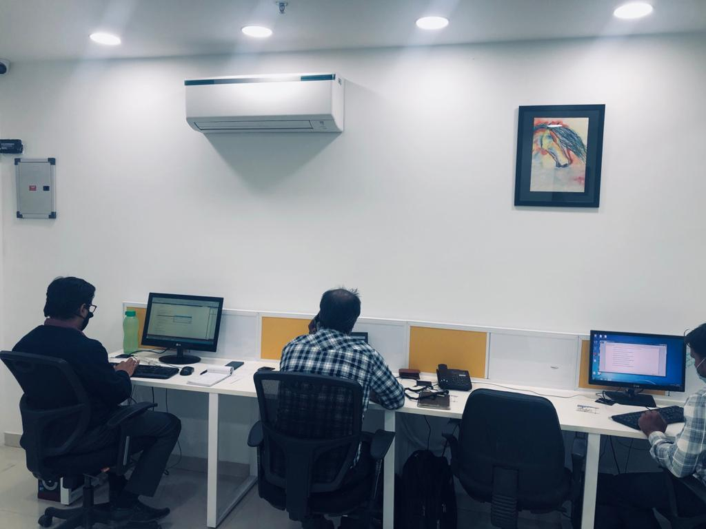**1.2 NEED FOR THE PROJECT/ PROBLEM STATEMENT:**

**1.1 FIG :WORK SPACE (Source: CM COMPUTERS)**

**As,** It is mentioned above and considering the following points For the Solution:

A huge chunk of Time & Finances of any rganization is Invested in creating hardcopy portfolios, banners and templeate (**With Respect to website rganizatio** ) for the

* **Marketing**
* **Reaching out to more clients for the Project Agreements**
* **Explansion of the product or service in the market**
* **Improving the Standards of their firm**

**In Resolving the Issues of the clients:**

1.Dealing with daily issues of the clients placed in the various companies associated with the firm.

2**.Focusing on the field of Data Maintaineance and query generation** becomes a daunting task for any rganization intackleing with the same problems multiple times with various companies.

3. A huge chunck **of precious time of any firm or organization is wasted** when it comes down into handling their clients basic queries over time to time.

4**. Resolving the same type of queries** in numerous amount can be really a daunting task.

|  |  |
| --- | --- |
| **SOFTWARE COMPONENTS** | **HARDWARE COMPONENTS** |
| 1.NOTEPAD OR SUBLIME TEXT EDITOR | 1.PROGRAMME EXECUTABLE MACHINE  (USED : LAPTON “DELL”(3.7,32 BITS)) |
| 2. XAMPP SOFTWARE  Updating PHP version with XAMPP – corbpie | 2.CAMERA(TO CAPTURE PICTURES OF THE ORGANISATION FOR THE WEB DEVELOPMENT) |
| 3.ALL DLL FILES TO RUN XAMPP |  |
| 4.APACHE(XAMPP SOFTWARE) |  |
| 6.SQL SERVER (XAMPP) |  |
| 7.STABLE INTERNET FOR THE LOCALHOST |  |
| 8.COMAND PROMT(CONNECTION ESTABLISH FOR SQL DATABASE) |  |

**CHAPTER 2**

**CHAPTER 3:**

**LANGUAGES USED FOR CODING**



**3.1 GOOGLE IMAGES**

* **HYPER TEXT MARKUP LANGUAGE (HTML)**

HTML, is been used in the project majourly to work as the front language for the static display of the content within the project.

Being easy to execute it on the system with easy commands for the web development

Easy for the understanding for the programmer to write the code

Simple usage of the basic commands deals for instance paragraph tags, image tags, table tags, font attributes, video tags, audio etc.

A simple text editor (Eg. Notepad ) which is preinstalled in most of the systems can be used for the execution of the command on any web browser.

Easy generation of forms in order to take the data from the user

**PHP :**

**3.2 GOOGLE IMAGES**

* PHP programs are written using a text editor, such as Notepad, Simple Text, or vi, just like HTML pages. However, unlike HTML, PHP files end with a .php extension. This extension signifies to the server that it needs to parse the PHP code before sending the resulting HTML code to the viewer ’ s web browsers.
* As you can see in the previous example, using PHP code to output plaintext results in rather bland pages. You can make them look more professional and less utilitarian by adding some HTML to your output. HTML can be inserted within your PHP block of code using the echo statement. In fact, anything you can code in HTML can be output from within a PHP section of code
* Apache, MySQL, and PHP are all open source projects that can be installed on a wide variety of platforms. They are most popular on Linux (giving the acronym “ LAMP ” ) although Windows - based Apache, MySQL and PHP installations are becoming increasingly popular, especially for developers.

**MY SQL**



**3.3 GOOGLE IMAGES**

* Implement a data manipulation language, which can directly access and update the database However, because the relative power of clients has grown considerably, we could shift processing to the client, but then keeping all clients current with application updates is difficult

**Architectures for Database Access**

• *A solution to the problems of two-tier systems is to add a component in the middle to create a three-tier system*

• For Web-based database access, the middle tier can run applications (client just gets results)

* *MySQL is a free, efficient, widely used SQL implementation and is available from http://www.mysql.org*

**CHAPTER 4**

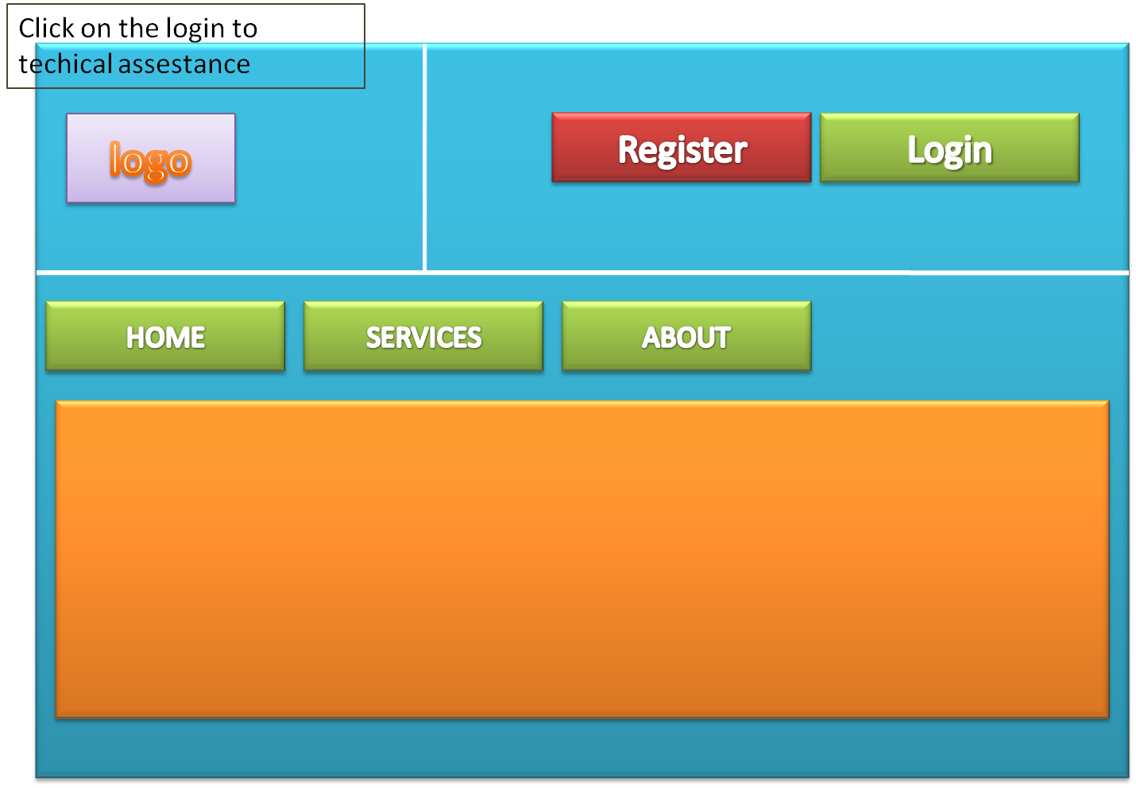

**FIG 4.1**

FONT PAGE ON THE WEBSITE MUST INCLUDE THE INFORMATION ABOUT THE ORGANISATION

With Buttons of **HOME, SERVICES, ABOUT, DEMO, FOLLOWED BY REGISTRATION AND LOGIN BUTTON**

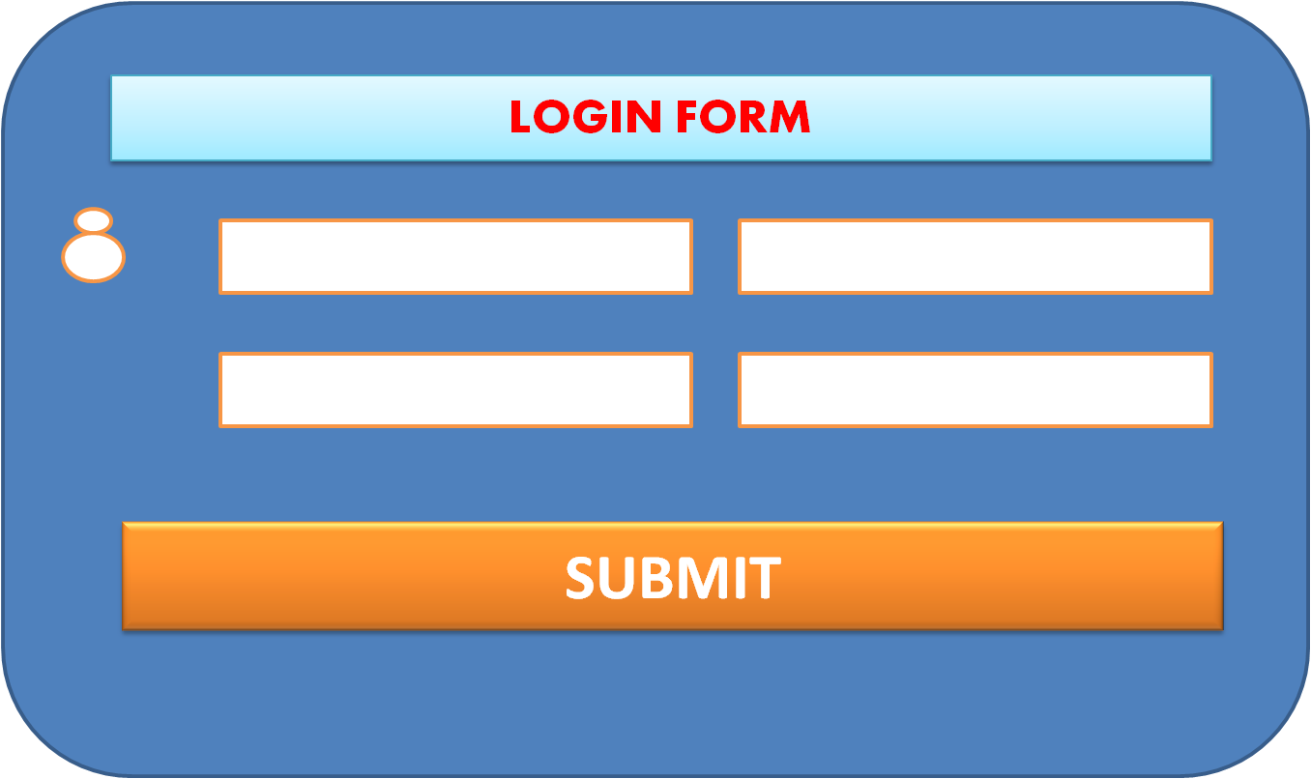**2. AN OVERVIEW OF THE EXPECTED OUTPUT OF LOGIN AND REGISTRATION FORM:**

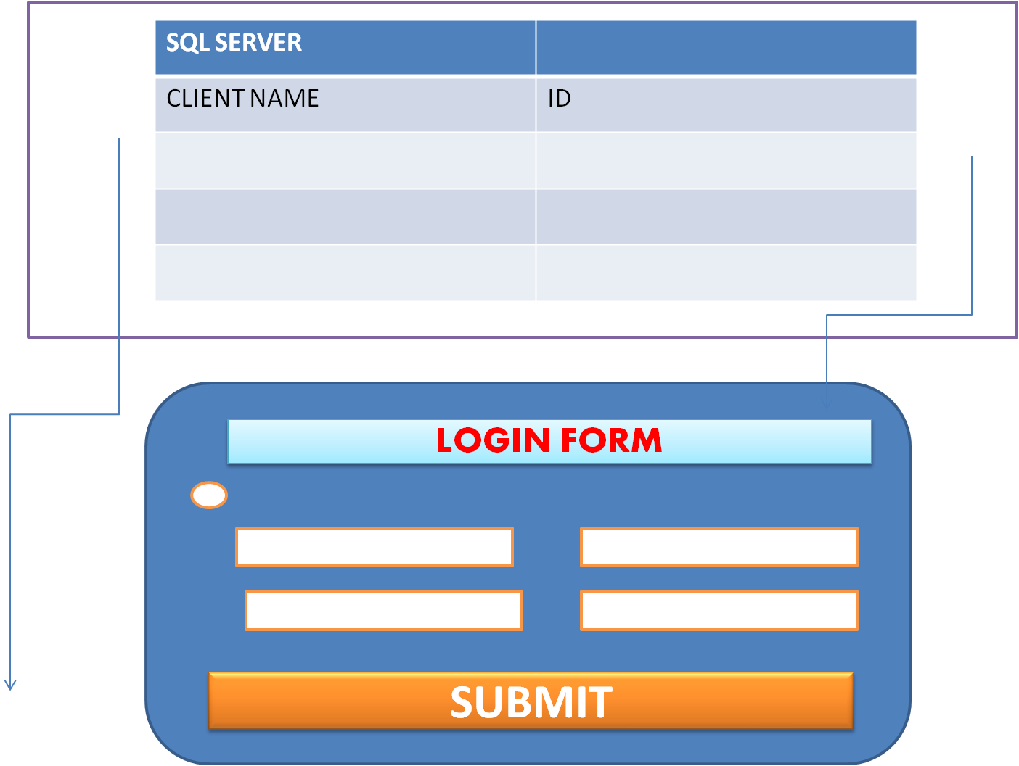

**3. TO DESCRIBLE HOW TO STORE THE DATA IN THE DATA BASE:**

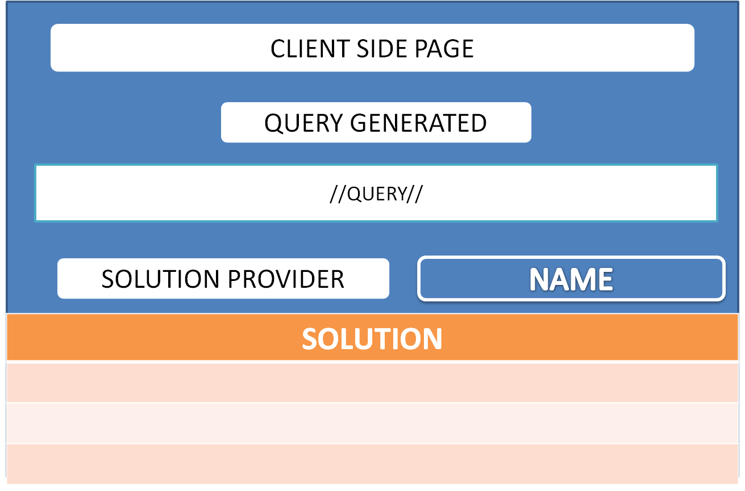

**EXPECTED OUTPUT OF THE RESULT**

**FIG 4.4**

**CHAPTER : 5**

**(CODE AND IMPEMENTATION)**

**1. CODE FOR THE HOME PAGE WHICH INCLUDES THE**

* **HOME BUTTON**
* **ABOUT US AND SERVICES**
* **REQUEST DEMO**
* **REGISTER**
* **LOGIN**

<!DOCTYPE html>

<html>

<title></title>

<head>

<meta name="viewport" content="width=device-width, initial-scale=1">

<meta content="text/html; charset=iso-8859-2" http-equiv="Content-Type">

<link rel="stylesheet" href="https://www.w3schools.com/w3css/4/w3.css">

<style>

.mySlides {display:none;}

</style>

<style type ="text/css">

.button{

padding: 16px 32px;

text-align: center;

text-decoration: none;

font-size: 20px;

margin: 8px 4px;

transition-duration: 0.4s;

cursor:pointer;

color: #ffffff;

background-color: #7aa8b7;

border-radius: 6px;

}

.button{

background-color: #00CC00;

color:white;

border: 2px #00CC00;

}

.button:hover {

background-color: #00FF00;

color:white;

}

}

</style>

</head>

<body>

<img src="logo2.png" align="left"><br/><br/><br/><br/>&nbsp;&emsp;&emsp;&emsp;&nbsp;&emsp;&emsp;&emsp;&nbsp;&emsp;&emsp;&emsp;&nbsp;&emsp;&emsp;&emsp;&nbsp;&emsp;&emsp;&emsp;&nbsp;&emsp;&emsp;&emsp;&nbsp;&emsp;&emsp;&emsp;&nbsp;&emsp;&emsp;&emsp;&nbsp;&emsp;&emsp;&emsp;&nbsp;&emsp;&emsp;&emsp;&nbsp;&emsp;&emsp;&emsp;&nbsp;&emsp;&emsp;&emsp;&nbsp;&emsp;&emsp;&emsp;&nbsp;&emsp;&emsp;&emsp;&nbsp;&emsp;&emsp;&emsp;&nbsp;&emsp;&emsp;&emsp;&nbsp;&emsp;&emsp;&emsp;&nbsp;&emsp;&emsp;&emsp;&nbsp;&emsp;&nbsp;&emsp;&emsp;&emsp;&emsp;&emsp;&emsp;&emsp;<a class ="button" href="file:///C:/Users/ANKIT/Desktop/MINI%20PROJECT3/formminiproject.html" align="border-top-right-radius"> <b> Register </b></button></a> <a class ="button" href="file:///C:/Users/ANKIT/Desktop/MINI%20PROJECT3/MAIN%20PROJECT_WEBSITE.html" align="border-top-right-radius"> <b> Login </b></button></a></font>

<a class ="button" href="file:///C:/Users/ANKIT/Desktop/MINI%20PROJECT3/MAIN%20PROJECT_WEBSITE.html" align="border-top-right-radius"> <b>

HOME</b></button></a> <a class ="button" href="file:///C:/Users/ANKIT/Desktop/MINI%20PROJECT3/ABOUT.HTML" align="border-top-right-radius"> <b> About Us & Services </b></button></a> <a class ="button" href="https://www.w3schools.com/tags/tag_button.asp" align="border-top-right-radius"> <b>REQUEST DEMO</b></button></a><br/>

<br/>

<img class="mySlides" src="banner1.png" >

<img class="mySlides" src="banner2.png">

<img class="mySlides" src="3.jpeg" height="700" width="1500">

</div>

<script>

var myIndex = 0;

carousel();

function carousel() {

var i;

var x = document.getElementsByClassName("mySlides");

for (i = 0; i < x.length; i++) {

x[i].style.display = "none";

}

myIndex++;

if (myIndex > x.length) {myIndex = 1}

x[myIndex-1].style.display = "block";

setTimeout(carousel, 2000); // Change image every 2 seconds

}

</script>

</body>

</html>

**CODE 2:**

**ABOUT PAGE**

<!DOCTYPE HTML>

<!DOCTYPE html>

<html>

<head>

<title>ABOUT CM COMPUTERS</title>

<style type ="text/css">

.button{

padding: 16px 32px;

text-align: center;

text-decoration: none;

font-size: 20px;

margin: 8px 4px;

transition-duration: 0.4s;

cursor:pointer;

color: #ffffff;

background-color: #7aa8b7;

border-radius: 6px;

}

.button{

background-color: #00CC00;

color:white;

border: 2px #00CC00;

}

.button:hover {

background-color: #00FF00;

color:white;

}

}

</style>

</head>

<body>

<img src="logo2.png" align="left"><br/><br/><br/><br/><br/> &nbsp;&emsp;&emsp;&emsp;&nbsp;&emsp;&emsp;&emsp;&nbsp;&emsp;&emsp;&emsp;&nbsp;&emsp;&emsp;&emsp;&nbsp;&emsp;&emsp;&emsp;&nbsp;&emsp;&emsp;&emsp;&nbsp;&emsp;&emsp;&emsp;&nbsp;&emsp;&emsp;&emsp;&nbsp;&emsp;&emsp;&emsp;&nbsp;&emsp;&emsp;&emsp;&nbsp;&emsp;&emsp;&emsp;&nbsp;&emsp;&emsp;&emsp;&nbsp;&emsp;&emsp;&emsp;&nbsp;&emsp;&emsp;&emsp;&nbsp;&emsp;&emsp;&emsp;&nbsp;&emsp;&emsp;&emsp;&nbsp;&emsp;&emsp;&emsp;&nbsp;&emsp;&emsp;&emsp;&nbsp;&emsp;&nbsp;&emsp;&emsp;&emsp;<a class ="button" href="file:///C:/Users/ANKIT/Desktop/MINI%20PROJECT3/formminiproject.html" align="border-top-right-radius"> <b> Register </b></button></a> <a class ="button" href="file:///C:/Users/ANKIT/Desktop/MINI%20PROJECT3/MAIN%20PROJECT_WEBSITE.html" align="border-top-right-radius"> <b> Login </b></button></a>

<p><section><a class ="button" href="file:///C:/Users/ANKIT/Desktop/MINI%20PROJECT3/MAIN%20PROJECT_WEBSITE.html" align="border-top-right-radius"> <b> HOME</b></button></a> <a class ="button" href="file:///C:/Users/ANKIT/Desktop/MINI%20PROJECT3/ABOUT.HTML" align="border-top-right-radius"> <b>ABOUT Us & SERVICES </b></button></a> <a class ="button" href="https://www.w3schools.com/tags/tag_button.asp" align="border-top-right-radius"> <b>REQUEST DEMO</b></button></a><br/>

</section></p>

<br/>

<p> <H3><centre> &nbsp;&emsp;&emsp;&emsp;&nbsp;&emsp;&emsp;&emsp;&nbsp;&emsp;&emsp;&emsp;&nbsp;&emsp;&emsp;&emsp;&nbsp;&emsp;&emsp;&emsp;&nbsp;&emsp;&emsp;&emsp;&nbsp;&emsp;&emsp;&emsp;&nbsp;&emsp;&emsp;&emsp;&nbsp;&emsp;&emsp;&emsp;&nbsp;&emsp;&emsp;&emsp;&nbsp;&emsp;&emsp;&emsp; OUR CLIENTS</H3><hr>

<marquee><img src="client1.png"> &nbsp; <img src="client3.jpg"> <img src=" client4.png"> <img src="client5.png"> <img src="client6.jpg"> <img src="client2.jpg"></marquee> </p>

<video width="500" height="500" controls>

<source src="video1.mp4" type="video/mp4">

<source src="movie.ogg" type="video/ogg">

</video>

</body>

</html>

**CODE 3:**

**REGISTERATION AND LOGIN PAGE**

<!DOCTYPE html>

<html>

<head>

<title>FORM 1</title>

<style type ="text/css">

.button{

padding: 16px 32px;

text-align: center;

text-decoration: none;

font-size: 20px;

margin: 8px 4px;

transition-duration: 0.4s;

cursor:pointer;

color: #ffffff;

background-color: #7aa8b7;

border-radius: 6px;

}

.button{

background-color: #00CC00;

color:white;

border: 2px #00CC00;

}

.button:hover {

background-color: #00FF00;

color:white;

}

}

</style>

</head>

<body>

<img src="logo2.png" align="left"><br/><br/><br/><br/><br/> &nbsp;&emsp;&emsp;&emsp;&nbsp;&emsp;&emsp;&emsp;&nbsp;&emsp;&emsp;&emsp;&nbsp;&emsp;&emsp;&emsp;&nbsp;&emsp;&emsp;&emsp;&nbsp;&emsp;&emsp;&emsp;&nbsp;&emsp;&emsp;&emsp;&nbsp;&emsp;&emsp;&emsp;&nbsp;&emsp;&emsp;&emsp;&nbsp;&emsp;&emsp;&emsp;&nbsp;&emsp;&emsp;&emsp;&nbsp;&emsp;&emsp;&emsp;&nbsp;&emsp;&emsp;&emsp;&nbsp;&emsp;&emsp;&emsp;&nbsp;&emsp;&emsp;&emsp;&nbsp;&emsp;&emsp;&emsp;&nbsp;&emsp;&emsp;&emsp;&nbsp;&emsp;&emsp;&emsp;&nbsp;&emsp;&nbsp;&emsp;&emsp;&emsp;<a class ="button" href="file:///C:/Users/ANKIT/Desktop/MINI%20PROJECT3/MAIN%20PROJECT_WEBSITE.html" align="border-top-right-radius"> <b> Register </b></button></a> <a class ="button" href="file:///C:/Users/ANKIT/Desktop/MINI%20PROJECT3/MAIN%20PROJECT_WEBSITE.html" align="border-top-right-radius"> <b> Login </b></button></a>

<p><section><a class ="button" href="file:///C:/Users/ANKIT/Desktop/MINI%20PROJECT3/MAIN%20PROJECT_WEBSITE.html" align="border-top-right-radius"> <b> HOME</b></button></a> <a class ="button" href="file:///C:/Users/ANKIT/Desktop/MINI%20PROJECT3/ABOUT.HTML" align="border-top-right-radius"> <b>ABOUT Us & SERVICES </b></button></a> <a class ="button" href="https://www.w3schools.com/tags/tag_button.asp" align="border-top-right-radius"> <b>REQUEST DEMO</b></button></a><br/>

</section></p>

<br/><br/>

<h2><hr color="green">

&nbsp;&emsp;&emsp;&emsp;&nbsp;&emsp;&emsp;&emsp;&nbsp;&emsp;&emsp;&emsp;&nbsp;&emsp;&emsp;&emsp;&nbsp; FORM FOR ID GENERATION </h2>&nbsp;&emsp;&emsp;&emsp;&nbsp;&emsp;&emsp;&emsp;&nbsp;&emsp;&emsp;&emsp;&nbsp;&emsp;&emsp;&emsp;&nbsp;&emsp;&emsp;&emsp;&nbsp;&emsp;&emsp;&emsp;&nbsp;&emsp;&emsp;&emsp;&nbsp;&emsp;&emsp;<img src="icon user.png" height="15%" width="15%"> &nbsp;&emsp;&emsp;&emsp;&nbsp;&emsp;&emsp;&emsp;&nbsp;&emsp;&emsp;&emsp;&nbsp;&emsp;&emsp;&emsp;&nbsp;&emsp;&emsp;&emsp;&nbsp;&emsp;&emsp;&emsp;&nbsp;&emsp;&emsp;<form action=" " method="post">

&nbsp;&emsp;&emsp;&emsp;&nbsp;&emsp;&emsp;&emsp;&nbsp;&emsp;&emsp;&emsp;&nbsp;&emsp;&emsp;&emsp;&nbsp;&emsp;&emsp;&emsp;&nbsp;&emsp;&emsp;&emsp;&nbsp;&emsp;&emsp;<label><b>ENTER YOUR NAME &emsp; </b></label>&emsp;<input type="text" name="uname"/><br/></br/>

&nbsp;&emsp;&emsp;&emsp;&nbsp;&emsp;&emsp;&emsp;&nbsp;&emsp;&emsp;&emsp;&nbsp;&emsp;&emsp;&emsp;&nbsp;&emsp;&emsp;&emsp;&nbsp;&emsp;&emsp;&emsp;&nbsp;&emsp;&emsp;<label><b>ENTER COMPANY NAME </b></label> <input type="text" name="cname"/>

<h3>&nbsp;&emsp;&emsp;&emsp;&nbsp;&emsp;&emsp;&emsp;&nbsp;&emsp;&emsp;&emsp;&nbsp;&emsp;&emsp;&emsp;&nbsp;&emsp;&emsp;&emsp;&nbsp;&emsp;&emsp;ID GENERATE</h3>

&nbsp;&emsp;&emsp;&emsp;&nbsp;&emsp;&emsp;&emsp;&nbsp;&emsp;&emsp;&emsp;&nbsp;&emsp;&emsp;&emsp;&nbsp;&emsp;&emsp;&emsp;&nbsp;&emsp;&emsp;&emsp;&nbsp;&emsp;&emsp;<label>Please Enter the ID </label><input type="text" name="id"/>

<p>

&nbsp;&emsp;&emsp;&emsp;&nbsp;&emsp;&emsp;&emsp;&nbsp;&emsp;&emsp;&emsp;&nbsp;&emsp;&emsp;&emsp;&nbsp;&emsp;&emsp;&emsp;&nbsp;&emsp;&emsp;&emsp;&nbsp;&emsp;&emsp;1.ID should contain 5 characters</p>

<p>

&nbsp;&emsp;&emsp;&emsp;&nbsp;&emsp;&emsp;&emsp;&nbsp;&emsp;&emsp;&emsp;&nbsp;&emsp;&emsp;&emsp;&nbsp;&emsp;&emsp;&emsp;&nbsp;&emsp;&emsp;&emsp;&nbsp;&emsp;&emsp;2. ID should contain atleast 1 Uppercase letter</p>

<p>

&nbsp;&emsp;&emsp;&emsp;&nbsp;&emsp;&emsp;&emsp;&nbsp;&emsp;&emsp;&emsp;&nbsp;&emsp;&emsp;&emsp;&nbsp;&emsp;&emsp;&emsp;&nbsp;&emsp;&emsp;&emsp;&nbsp;&emsp;&emsp;3. ID should contain 1 special character @,&,*,$ </p><br/>

&nbsp;&emsp;&emsp;&emsp;&nbsp;&emsp;&emsp;&emsp;&nbsp;&emsp;&emsp;&emsp;&nbsp;&emsp;&emsp;&emsp;&nbsp;&emsp;&emsp;&emsp;&nbsp;&emsp;&emsp;&emsp;&nbsp;&emsp;&emsp;<a class ="button" href="file:///C:/Users/ANKIT/Desktop/MINI%20PROJECT3/MAIN%20PROJECT_WEBSITE.html" align="border-top-right-radius"> <input type="SUBMIT" value="submitdetails"></button></a><b> </b>

<br/><br/><br/>

<hr color="green">

</form>

</body>

</html>

**CODE :4**

**PHP & SQL CONNECTION ESTABLISH**

<? php

$servername="localhost";

$username="root";

$password=" ";

$database_name="employee";

$conn=mysqli_connect($server_name,$username,$password,$database_name);

if(! $conn)

{

die("connection failed",mysql_connect_error());

}

if(isset($post['save']))

$name=$_post['name'];

$cname=$_post['cname'];

$id=$_post['id'];

$sql_query="INSERT INTO company_employee_details(name,cname,id)VALUES('$name','$c_name','$id')";

if(mysqli_query($conn,$sql_query))

{ echo("successfully!")

}

**CHAPTER 6:**

**OUTPUT OF THE PROJECT:**

**(INCLUDES SCREENSHOTS OF THE OUTPUT)**

1. HOME PAGE (WEBSITE)

* **LOGO**
* **SLIDE SHOW**
* **BUTTONS WITH HOVER EFFECT**
* **HOME ,ABOUT US AND SERVICES, REQUEST DEMO,REGISTER AND LOGIN.**

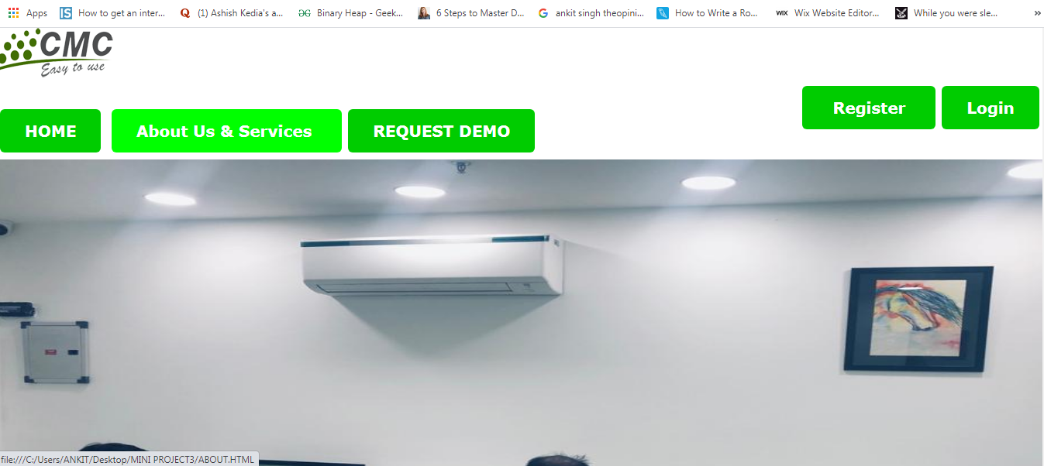**FIG 6.1**

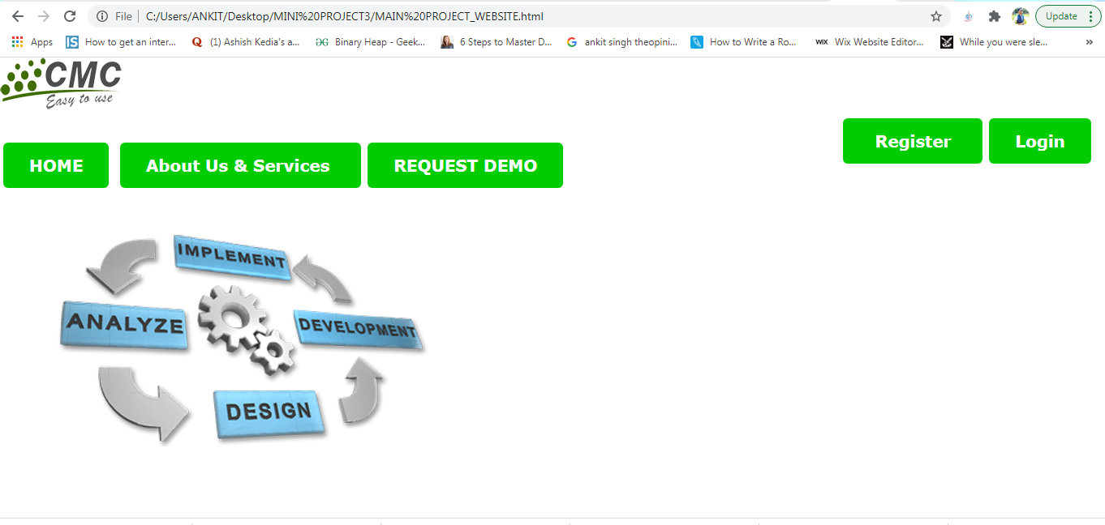

**2. ABOUT US AND SERVICES**

* **THE CLIENTS LOGO’S(USING MARQUEE)**
* **A VIDEO**
* 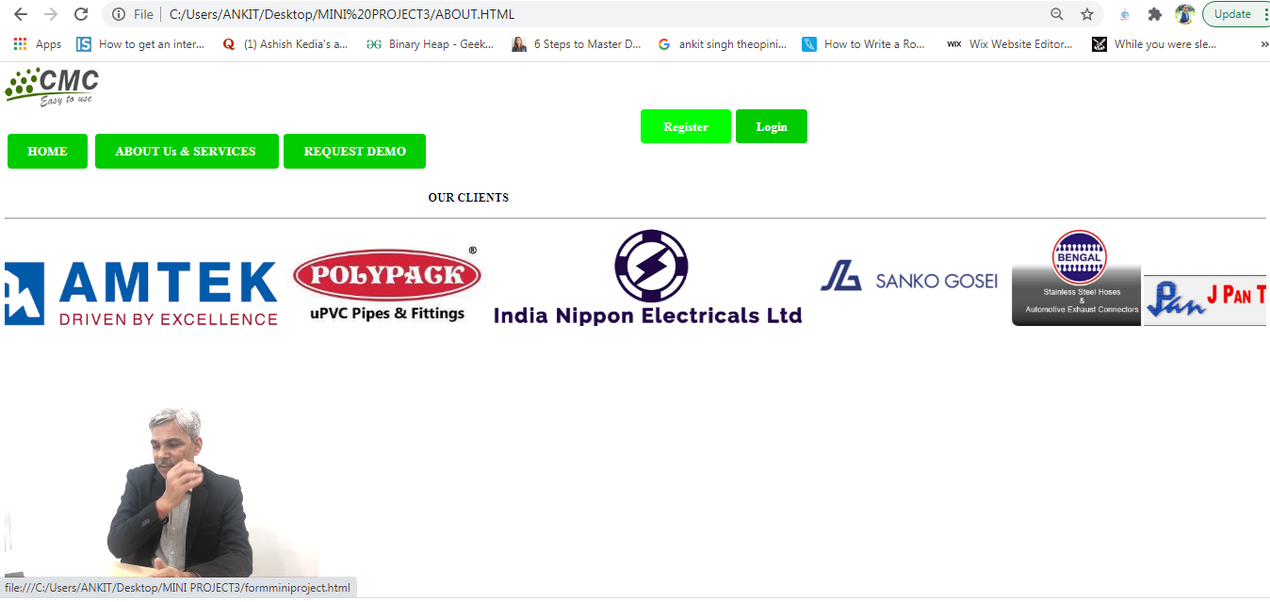**BUTTONS**

**FIG 6.3**

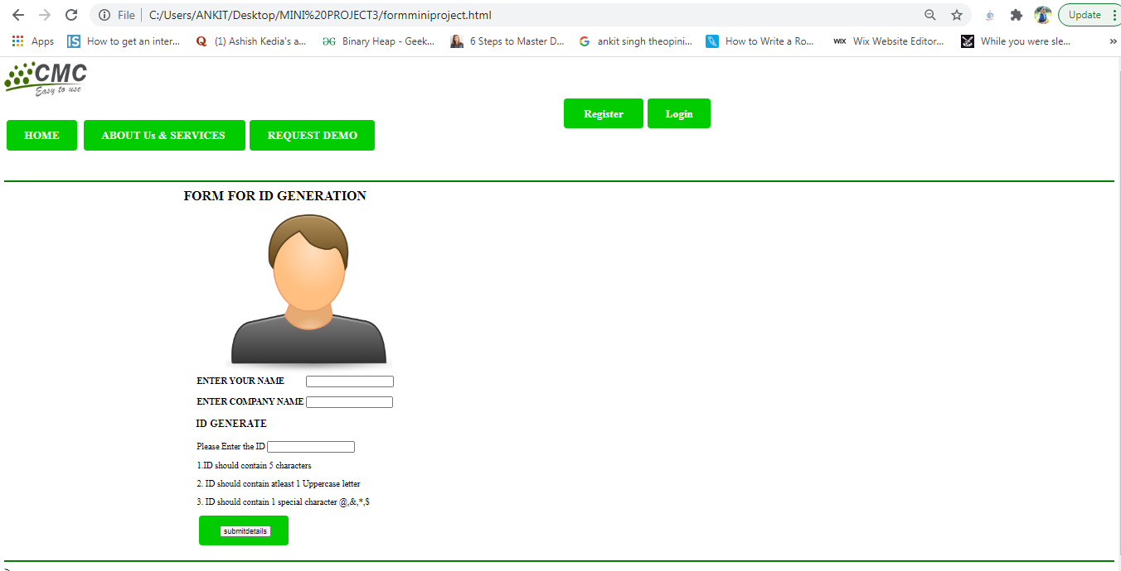**3. REGISTER page**

** LOGIN PAGE:**

**CHAPTER 7:**

**CONCLUSION:**

In conclusion, I would like to say that through this project, It had helped me to get my programming skills much better and unleash my skills in coding.

It had build some amount of awareness within us about the need and importance of the web development , while doing the project which helps us to understand how any big or small programme

WEBSITE-BUILDING is a fun activity apart from our usual studies , applying practical knowledge makes it way more better and build a some sort of confidence in our programming skills apart of classroom studies and lab-practical’s.

Through thePROGRAMME ,I have an confidence that this can bring a change at least in someone’s life .

I would like to THANK all the teacher’s who had thought me the programming language and non-programming teachers, due to which It is possible for me to make it happen practically, I would like to thank NEW-HORIZON COLLEGE for giving me the opportunity to work on the project.

**BIBLOGRAPHY**

1.company official website: http://cmcomputers.in/

2. google images

3. W3 SCHOOLS for refrence

4. Youtube for the connection of html form with SQL data base on Xampp

5. google drive

6. hover effects of buttons using W3 SCHOOLs, and lots more.